CONTROL PC VOLUME USING ROTARY ENCODER

# A MINI PROJECT REPORT

***Submitted by***

|  |  |
| --- | --- |
| **Sobhika.R** | **113220031138** |
| **Nandhini.K** | **113220031080** |
| **Vinunithi.GN** | **113220031167** |

**BACHELOR OF ENGINEERING**

**IN**

# COMPUTER SCIENCE AND ENGINEERING



**VELAMMAL ENGINEERING COLLEGE**

## [An Autonomous Institution]

**ANNA UNIVERSITY: CHENNAI 600 025**

# APRIL 2022

**BONAFIDE CERTIFICATE**

Certified that this Mini project report “**Control PC volume using rotary encoder”** is the bonafide work of **Sobhika R(113220031138), Nandhini K (113220031080)** and **Vinunithi GN (113220031167)** who carried out the Mini project work under my supervision.

# SIGNATURE SIGNATURE

**Dr. P. PRITTO PAUL Dr.B.MURUGESHWARI**

**SUPERVISOR HEAD OF THE DEPARTMENT**

Computer Science and Engineering Computer Science and Engineering, Velammal Engineering College Velammal Engineering College,

Ambattur – Red hills Road, Ambattur–Red hills Road,

Chennai – 600066. Chennai – 600066.

2

# MINI PROJECT EXAMINATION

The MINI PROJECT Examination of this project work “**CONTROL PC VOLUME USING ROTARY ENCODER”** is a bonafide record of project done at the Department of Computer Science and Engineering, Velammal Engineering College during the academic year 2021– 2022 by

|  |  |
| --- | --- |
| **Sobhika R** | **113220031138** |
| **Nandhini K** | **113220031080** |
| **Vinunithi GN** | **113220031167** |

of Second year Bachelor of Engineering in Computer Science and Engineering submitted for the university examination held on

# INTERNAL EXAMINER EXTERNAL EXAMINER

**ABSTRACT**

A rotary encoder is a type of position sensor that converts the angular position (rotation) of a knob into an output signal that is used to determine what direction the knob is being rotated. Due to their robustness and fine digital control; they are used in many applications including robotics, CNC machines and printers. One of the key areas which need to be looked at while developing such systems is the code implementation stage. In order to manage the work we shall be using C for the implementation of the code. We feel that if we successfully meet our goals then we shall have contributed towards the future of natural gesture based interfaces, if only in a minimal way.

Since rotary encoders are basic components, they do not come pre-programmed and need to be programmed manually to perform the desired actions. You’ll also need to set up a build environment that will support your rotary encoder. A pre-built environment can be found here. Once you’ve set up your build environment, you can now program your rotary encoder to perform whatever action you need. This will require a bit of programming experience, but if you’re just looking to perform some basic functions like volume control and scrolling, the code snippets for some of those actions can be found here.

|  |  |  |
| --- | --- | --- |
|  | **TABLE OF CONTENTS** |  |
| **CHAPTER NO.** | **TITLE** | **PAGE NO.** |
|  | **ABSTRACT** | **4** |
|  | **LIST OF FIGURES** | **8** |
|  | **LIST OF ABBREVATIONS** | **9** |
| **1** | **INTRODUCTION** | **10** |
|  | 1.1 PURPOSE OF THE PROJECT | 10 |
|  | 1.2 TABULA-JAVA | 10 |
|  | 1.3 LAYERED ARCHITECTURE | 11 |
|  | 1.4 SCOPE OF THE PROJECT | 11 |
| **2** | **SYSTEM ANALYSIS** | **12** |
|  | 2.1 EXISTING SYSTEM | 12 |
|  | 2.1.1 DISADVANTAGES IN THE EXISTING SYSTEM | 12 |
|  | 2.2 PROPOSED SYSTEM | 12 |
|  | 2.2.1 ADVANTAGES IN THE PROPOSED SYSTEM | 13 |
|  | 5 |  |

|  |  |  |
| --- | --- | --- |
| **3** | **SYSTEM SPECIFICATION** | **14** |
|  | 3.1 HARDWARE REQUIREMENTS | 14 |
|  | 3.2 SOFTWARE REQUIREMENTS | 14 |
|  | 3.3 TECHNOLOGIES USED | 14 |
| **4** | **SYSTEM DESIGN** | **15** |
|  | 4.1 SYSTEM ARCHITECTURE DIAGRAM | 15 |
|  | 4.2 UML DIAGRAMS | 16 |
|  | 4.2.1 USECASE DIAGRAM | 17 |
|  | 4.2.2 CLASS DIAGRAM | 18 |
|  | 4.2.3 SEQUENCE DIAGRAM | 19 |
|  | 4.4 DATA FLOW DIAGRAM | 20 |
| **5** | **SYSTEM IMPLEMENTATION** | **21** |
|  | 5.1 MODULES | 21 |
|  | 5.2 MODULE DESCRIPTION | 21 |
|  | 5.2.1 Signup | 21 |
|  | 5.2.2 Login | 21 |
|  | 5.2.3 Admin side | 21 |
|  | 5.2.4 User side  5.2.5 User Profile  5.2.6 Management | 21  21  21 |
|  | 6 |  |

|  |  |  |
| --- | --- | --- |
| **6** | **CONCLUSION AND FUTURE WORK** | **22** |
|  | 6.1 CONCLUSION | 22 |
|  | 6.2 FUTURE WORK | 22 |
|  | **APPENDIX I- SOURCE CODE** | **26** |
|  | **APPENDIX II-SNAPSHOTS** | **81** |
|  | **REFERENCES** | **87** |

7

# LIST OF FIGURES

|  |  |  |
| --- | --- | --- |
| **F.NO** | **NAME OF THE FIGURE** | **PAGE NO** |
| 1.1 | Layered Architecture(3-tier) | 11 |
| 4.1 | System Architecture | 15 |
| 4.2 | Use Case Diagram | 17 |
| 4.3 | Class Diagram | 18 |
| 4.4 | Sequence Diagram | 19 |
| 4.5 | Data flow Diagram | 20 |

**CHAPTER 1**

**INTRODUCTION**

* 1. **PURPOSE OF THE PROJECT:**

# Implemented a simple Arduino and Rotary encoder to control PC volume

# • Control of PC Media player

# • To increase the volume.

# • To decrease the volume.

# • To change the tabs in website.

# • To control Power point presentation

# INTERNET OF THINGS

1. The internet of things helps people live and work smarter, as smarter, as well as gain complete to control over their lives. In addition to offering smart devices to automate homes, IOT is essential to business. IOT provides business with a real-time look into how their systems really works, delivering insights into everything from the performance of machines of supply chain and logistics operations.

# ARDUINO

Arduino is a open-source platform used for building electronics projects.Arduino consists of

physical programmable circuit board (often referred to as a micro controller) and a piece of

software, or IDE (Integrated Development Environment) that runs on your computer,used

to write and upload computer code to the physical board.The Arduino platform has become

quite popular with people with people just starting out with electronics and for good reason.

Unlike most previous programmable circuit boards., the Arduino does not need a separate

piece of hardware(called a programmer) in order to load new code onto the board--

you can simply use the USB cable. Additionally, the

# LAYERED ARCHITECTURE:

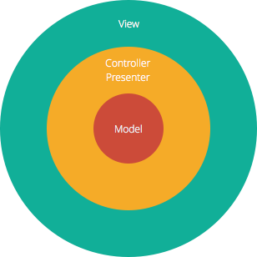The most common architecture pattern is the layered architecture pattern. This is also known as the n-tier architecture pattern. Components within the layered architecture pattern are organized into horizontal layers, each layer performing a specific role within the application (e.g., presentation logic or business logic). Although the layered architecture pattern does not specify the number and types of layers that must exist in the pattern, most layered architectures consist of four standard layers:

* + - Presentation layer (known as view layer)
    - Application layer (known as controller layer)
    - Domain layer (known as service layer)
    - Persistence layer (known as DAO layer)

*Fig: 1.1 Layered Architecture (3-tier) [4]*

The smaller applications may have only three layers, whereas larger and more complex business applications may contain five or more layers. Each layer of the layered architecture pattern has a specific role and responsibility within the application [5]. In this project, controller layer, service layer, DAO, model layer along with data transfer object (DTO) has been used.

# SCOPE OF THE PROJECT

# This paper introduces a technique based on determining distance by the sensor and according

# a particular function is performed. This project uses the HID library with a rotary switch as a digital volume control of PC sound.The push button connected to the encoder shaft is used is used as a mute, increase and decrease the volume. button.One side of the switch has two pins, that is push switch.The side with three switch contacts is the rotary part of the switch. Circuit power comes the USB connection.In order to control the PC using rotary encoder which enable

# us to control the functions on our computer/laptop. A rotary encoder detects the rotation of the center shaft and is used to control machinery position and motor speed, audio volumes(up and down), the cursor position on a LCD(Liquid Crystal Display) screen,or simply LED brightness.

**CHAPTER 2**

**SYSTEM ANALYSIS**

* 1. **EXISTING SYSTEM:**
* Early days Libraries are managed manually. It required lot of time to record or to retrieve the details.
* The employees who have to record the details must perform their job very carefully.
* Even a small mistake would create a lot of problems.
* Security of information is very less.
* Report generations of all the information is very tough task.
* Maintenance of Library catalogue and arrangement of the books to the catalogue is very complex task. In addition to its maintenance of member details, issue dates and return dates etc. manually is a complex task.
* All the operations must be performed in perfect manner for the maintenance of the library with out any degradation which may finally result in the failure of the entire system.

# DISADVANTAGES IN THE EXISTING SYSTEM

* + - * **Not User Friendly:** The existing system is not user friendly as searching of books take a lot of time
      * **Difficulty in using:** People eho are new to library find it difficult to search the books
      * **Manual control**: All record works have to be done manually

# PROPOSED SYSTEM

To solve the inconveniences as mentioned in the existing system, an Online Library is proposed which helps the library management authorities to have a perfect record of the books in the

# ADVANTAGES IN THE PROPOSED SYSTEM

* Individually each member can access the website through which he/she can access the information they needs.
* Book details like authors, number of copies totally maintained by library, present available number of books, reference books, non-reference books etc. all this information can be made handy.
* Regarding the members designation, number of books was issued.
* Administrator can add, update the books.
* Time consuming is low, gives accurate results, reliability can be improved with the help of security.

# CHAPTER 3

# SYSTEM SPECIFICAION

* 1. **HARDWARE REQUIREMENT**

1. Intel core i5 2nd generation is used as a processor because it is fast than other processors an provide reliable and stable and we can run our pc for longtime. By using this processor we can keep on developing our project without any worries.
2. Ram 1 gb is used as it will provide fast reading and writing capabilities and will in turn support in processing.

# SOFTWARE REQUIREMENT

* + - Operating system- Windows 7 is used as the operating system as it is stable and supports more features and is more user friendly
    - Database MYSQL-MYSQL is used as database as it easy to maintain and retrieve records by simple queries which are in English language which are easy to understand and easy to write.
    - Development tools and Programming language- HTML is used to write the whole code and develop webpages with css, java script for styling work and php for sever side scripting

# TECHNOLOGIES USED

* + - Java script
    - CSS

# CHAPTER 4

# SYSTEM DESIGN

* 1. **SYSTEM ARCHITECTURE**

A system architecture is the [conceptual model](https://en.wikipedia.org/wiki/Conceptual_model) that defines the [structure](https://en.wikipedia.org/wiki/Structure), [behavior](https://en.wikipedia.org/wiki/Behavior), and more [views](https://en.wikipedia.org/wiki/View_model) of a [system.](https://en.wikipedia.org/wiki/System) It is an important tool as it provides an overall view of the physical deployment of the software system and its evolution roadmap. An architecture description is a formal description and representation of a system, organized in a way that supports reasoning about the [structures](https://en.wikipedia.org/wiki/Structure) and [behaviors](https://en.wikipedia.org/wiki/Behavior) of the system. A system architecture can consist of system [components](https://en.wikipedia.org/wiki/System) and the sub-systems developed, that will work together to implement the overall system. There have been efforts to formalize languages to describe system architecture, collectively these are called ADL [7].

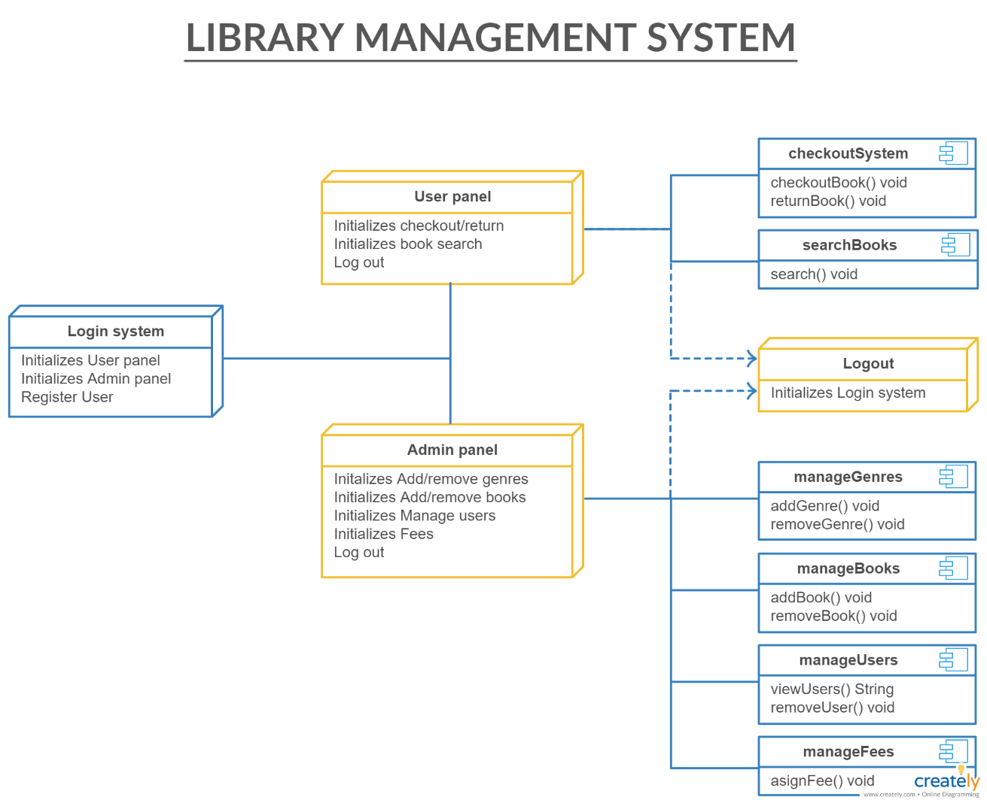

*Fig 4.1 Syste*1*m*5 *Architecture*

# UML DIAGRAMS

UML is a standard language for specifying, visualizing, constructing, and documenting the artifacts of software systems. It’s a rich language to model software solutions, application structures, and system behavior and business processes [8]. UML provides a comprehensive notation for the full lifecycle of OOD. UML is not a programming language but tools can be used to generate code in various languages using UML diagrams. The goal of UML can be defined as a simple modeling mechanism to model all possible practical systems in today’s complex environment.

# ADVANTAGES

* + 1. To represent complete systems (instead of only the software portion) using object oriented concepts.
    2. To establish an explicit coupling between concepts and executable code.
    3. To take into account the scaling factors that are inherent to complex and critical systems.
    4. To creating a modelling language usable by both humans and machines.

UML defines several models for representing systems

1. The use case model describes the requirements of the user.
2. The class model captures the static structure.
3. A sequence diagram simply depicts interaction between objects in a sequential order.

16

# USE CASE DIAGRAM

A use case diagram at its simplest is a representation of a user's interaction with the system and depicting the specifications of a use case. A use case diagram can portray the different types of users of a system and the various ways that they interact with the system.

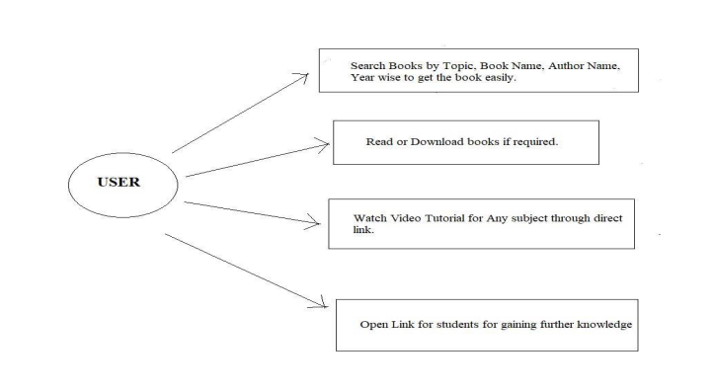

*Fig 4.2 Use case diagram*

# CLASS DIAGRAM

The class diagram is the main building block of object-oriented modeling. It is used for general conceptual modeling of the structure of the application, and for detailed modeling, translating the models into programming code. Class diagrams can also be used for data modeling. The classes in a class diagram represent both the main elements, interactions in the application, and the classes to be programmed. In the design of a system, a number of classes are identified and grouped together in a class diagram that helps to determine the static relations between them. In detailed modeling, the classes of the conceptual design are often split into subclasses [9].

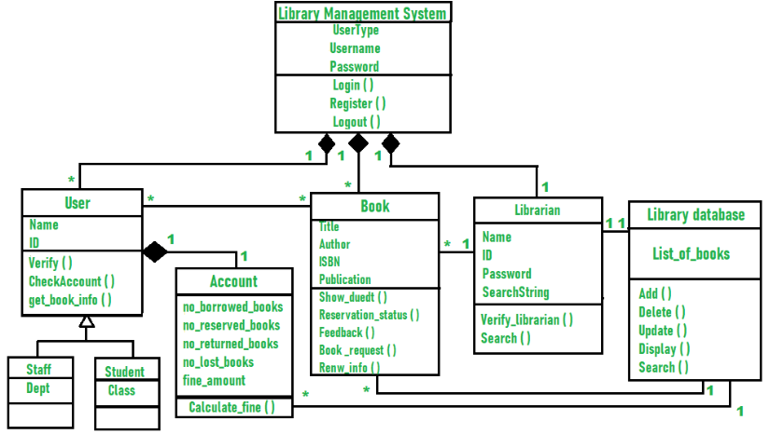

*Fig 4.3 Class Diagram*

# SEQUENCE DIAGRAM

A sequence diagram simply depicts interaction between objects in a sequential order, the order in which these interactions take place. Sequence diagrams describe how and in what order the objects in a system function. These diagrams are widely used by businessmen and software developers to document and understand requirements for new and existing systems.

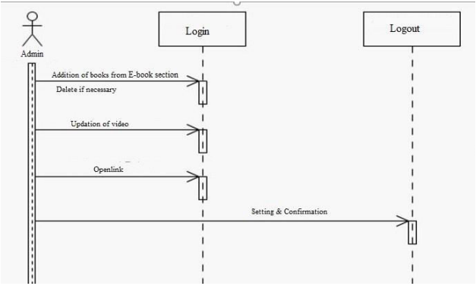

*Fig 4.4 Sequence Diagram*

# DATA FLOW DIAGRAM

A Data Flow Diagram (DFD) is a traditional visual representation of the information flows within a system. A neat and clear DFD can depict the right amount of the system requirement graphically. It can be manual, automated, or a combination of both.

It shows how data enters and leaves the system, what changes the information, and where data is stored.

The objective of a DFD is to show the scope and boundaries of a system as a whole. It may be used as a communication tool between a system analyst and any person who plays a part in the order that acts as a starting point for redesigning a system. The DFD is also called as a data flow graph or bubble chart [10].

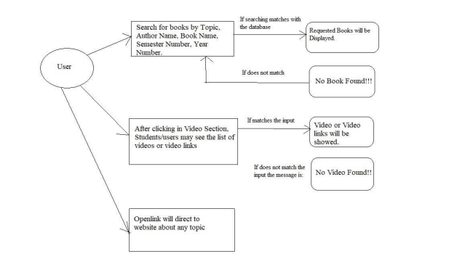

*Fig 4.5 Data flow diagram*

# CHAPTER 5

# SYSTEM IMPLEMENTATION

* 1. **MODULES**
     + Sign up
     + Login
     + Admin side
     + User side
     + User profile
     + Management

# MODULE DESCRIPTION

* + 1. **Sign up:**If the user don’t have an account, he/she cn register in this sign-up page and create an account here

## Login: The user can use the login page to enter their credentials A user can access the books only if they are a member of the library

## Admin side: The admin has the record of the books and the book details.The admin has a list of the books that are lended and not returned yet

## User side: Here, the user’s account details are mentioned.The list of books, the number of books the user has lended will be visible here

## User profile: The user’s details are seen here.The user can update or manipulate their details here

## Management: The user can search for their desired category,author,book here.The admin has the access to add or delete the list of books and students in this library

# CHAPTER 6 CONCLUSION AND FUTURE WORK

* 1. **CONCLUSION**

1. This website provides a computerized version of library management system which will benefit the students as well as the staff of the library. It makes entire process online where student can search books, staff can generate reports and do book transactions. It also has a facility for student login where student can login and can see status of books issued as well request for book or give some suggestions. It has a facility of teacher’s login where teachers can add lectures notes and also give necessary suggestion to library and also add info about workshops or events happening in our college or nearby college in the online notice board.

# FUTURE WORK

There is a future scope of this facility that many more features such as online lectures video tutorials can be added by teachers as well as online assignments submission facility , a feature Of group chat where students can discuss various issues of engineering can be added to this project thus making it more interactive more user friendly and project which fulfills each users need in the best way possible.

# APPENDIX 1 SOURCE CODE